**CHAPTER (1)**

**INTRODUCTION**

* 1. **Introduction**

This project is about the information of Tomorrow X Together and TXT is a 5-members boy group formed by Big Hit Music (part of HYBE Labels). The group consists of: Yeonjun, Soobin, Beomgyu, Taehyun and Huening Kai. They debuted on March 4th, 2019 with their first mini-album ‘The Dream Chapter: STAR’. This project contains their released albums, songs and has a website you can buy albums, merch, concert tickets.

* 1. **Objectives**
* To know their life style
* To listen their songs
* To watch their music video and dance
* To look their images

**CHAPTER (2)**

**BACKGROUND OF THE PROJECT**

2.1 **Background of the project**

About the K-pop idol group , you can view various sections that provide information about the TXT K-pop group, such as their history, members, discography and upcoming events. This website also include multimedia content, such as music audio, photo, weverse shop page and payment page. The website project is to create a platform where fans can connect with their favorite group and stay informed about their activities and releases.

This project is made of the first time. Completing a project is just the beginning of my journey. I learned many valuable things from this experience. I will try to improve my skills. I hope, users will enjoy my website.

**CHAPTER (3)**

**IMPLEMENTATION**

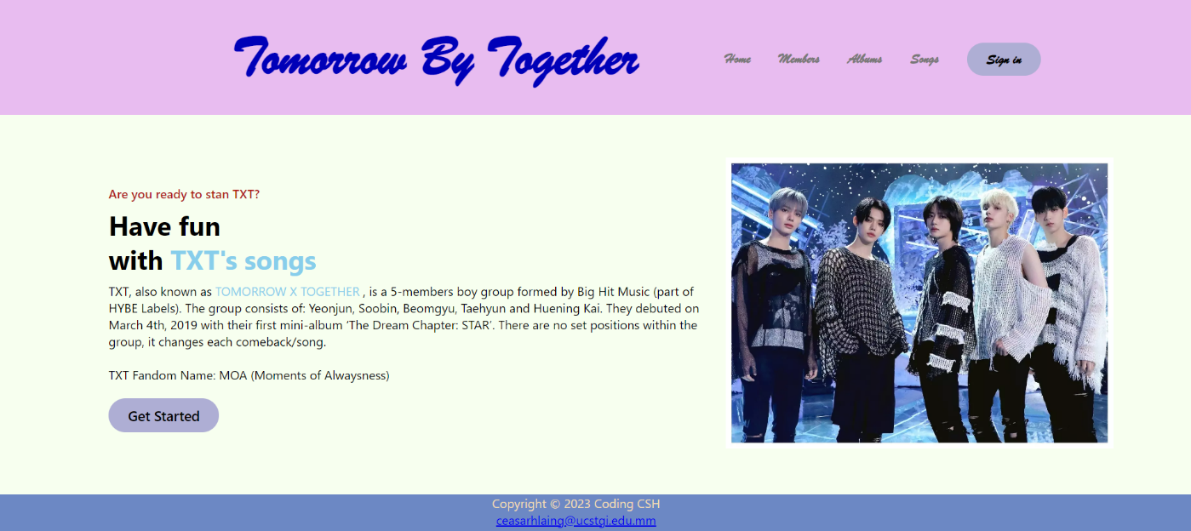

**Figure 3.1 Home Page**

At home page describes the information of the TXT group. If you want to know about the members go to Members Page.

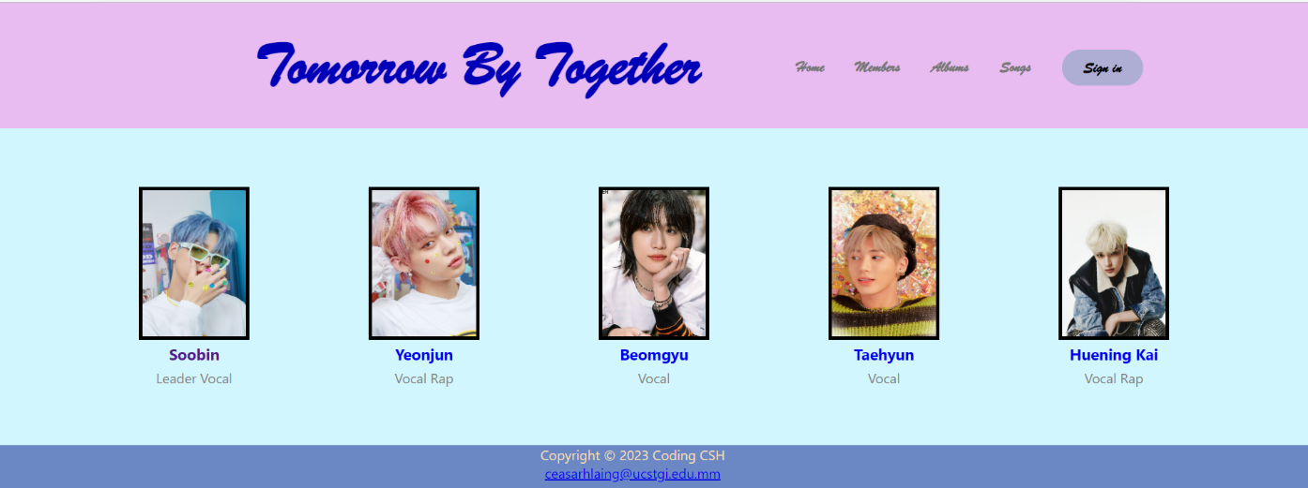

**Figure 3.2 Members Page**

This page includes the members of TXT. If you click on “Soobin” , you will reach to another page including his profile and facts ….another members are also like that.

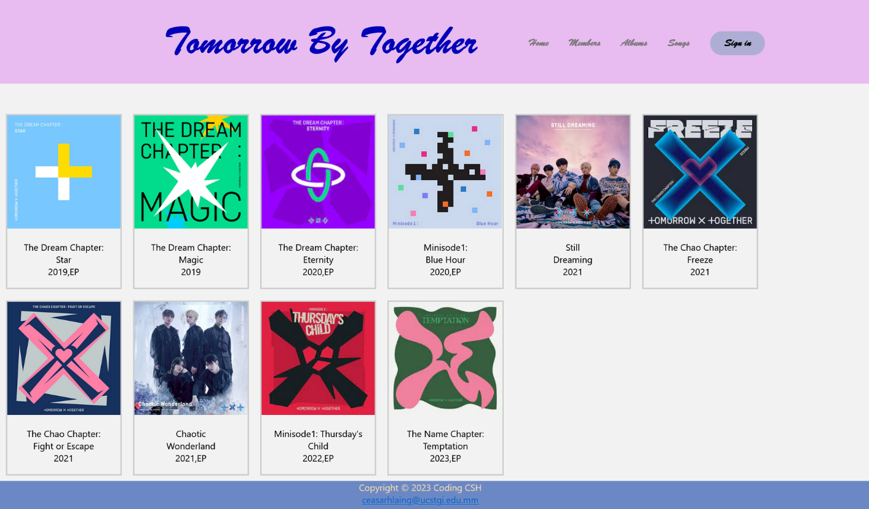

**Figure 3.3 Albums Page**

Figure 3.3 Albums Page, you will see the released albums of TXT group

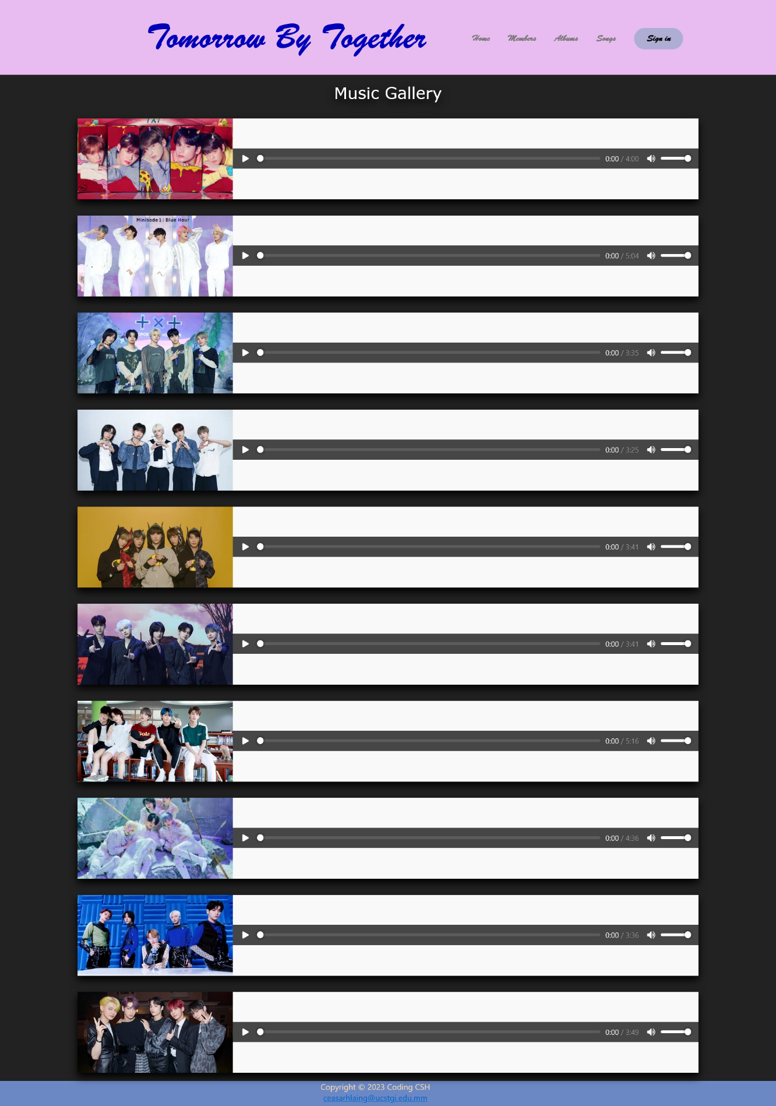

**Fig 3.4 Songs Page**

This page includes some of their songs. I added audios so that you can listen to the music and you can increase or decrease the volume as you wish.

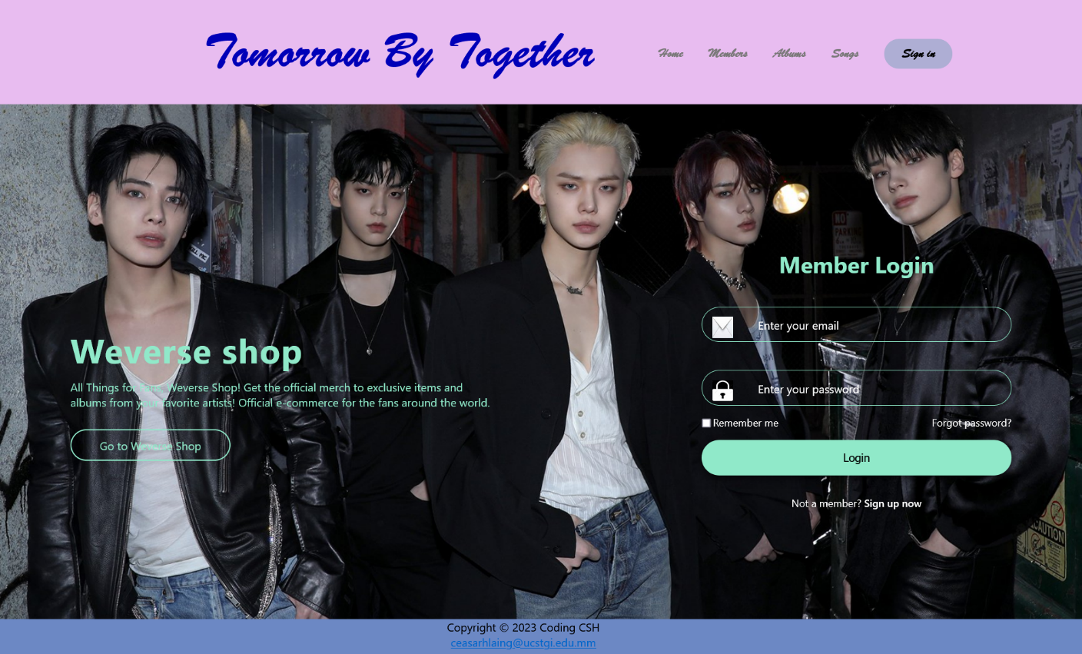

**Fig 3.5 Sign in Page**

In this page, you can login to Weverse Shop where you can buy items related to them. If you click on “Sign up now or Go to Weverse Shop” , you will reach to Weverse Shop page.

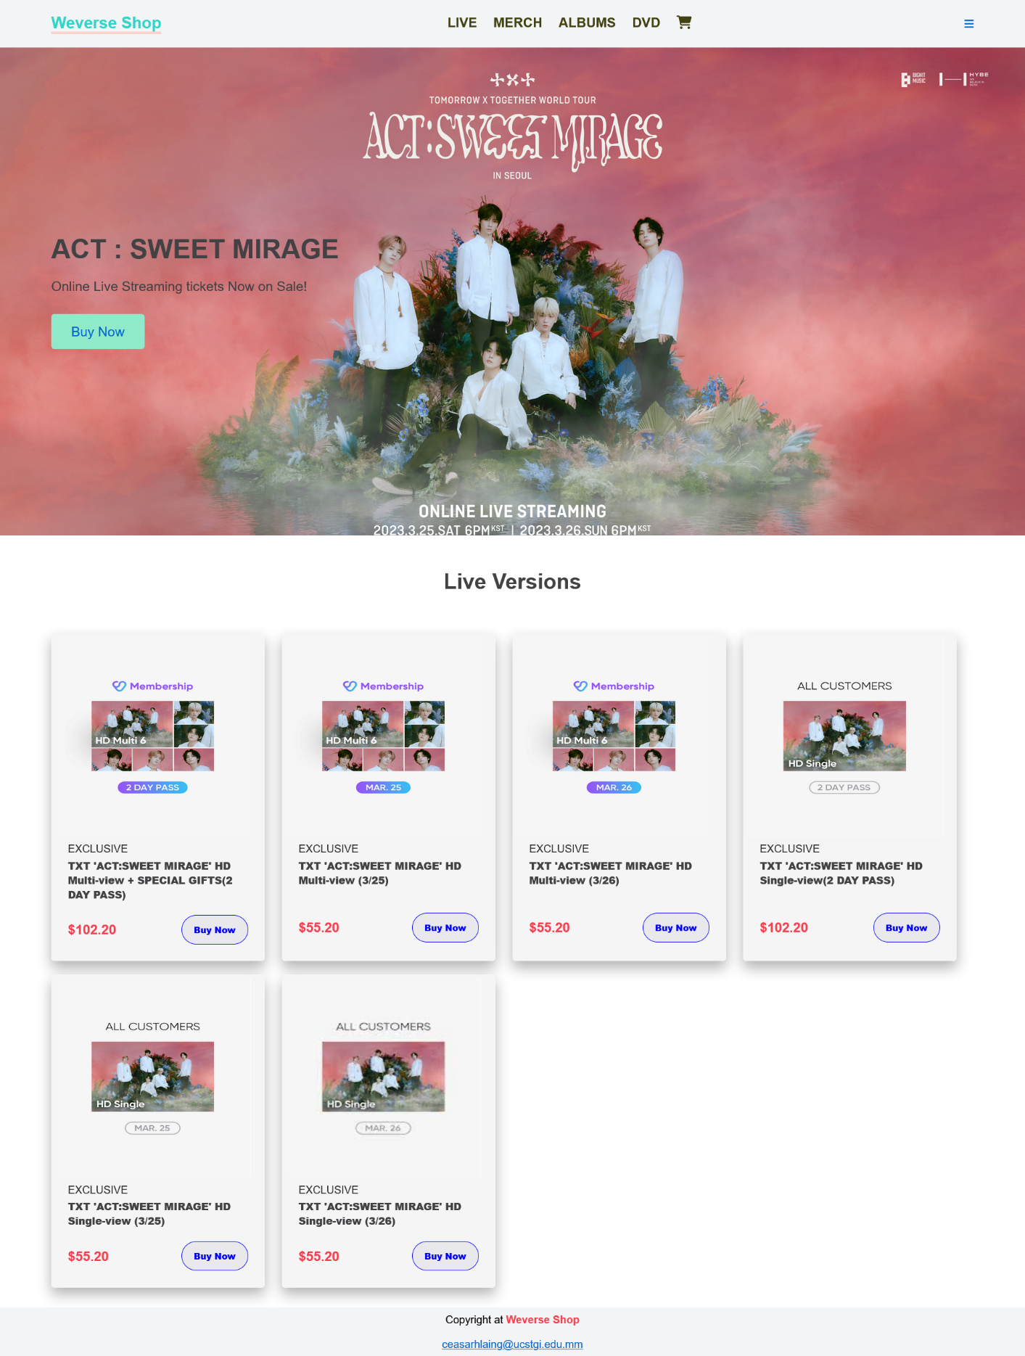

**Fig 3.6 LIVE Page**

Welcome to Weverse Shop! In this page, you can buy their online concert tickets. If you click on “Buy Now” , you will reach to Payment page.

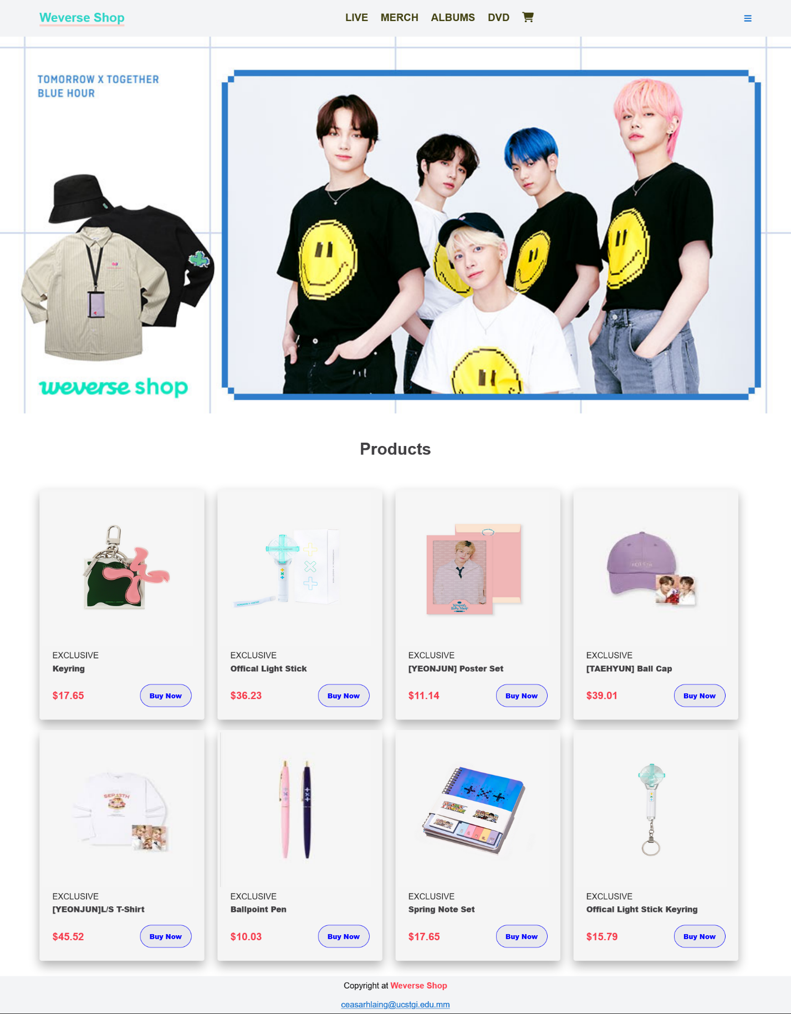

**Fig 3.7 MERCH Page**

Welcome to Weverse Shop! In this page, you can buy their products. If you click on “Buy Now” , you will reach to Payment page.

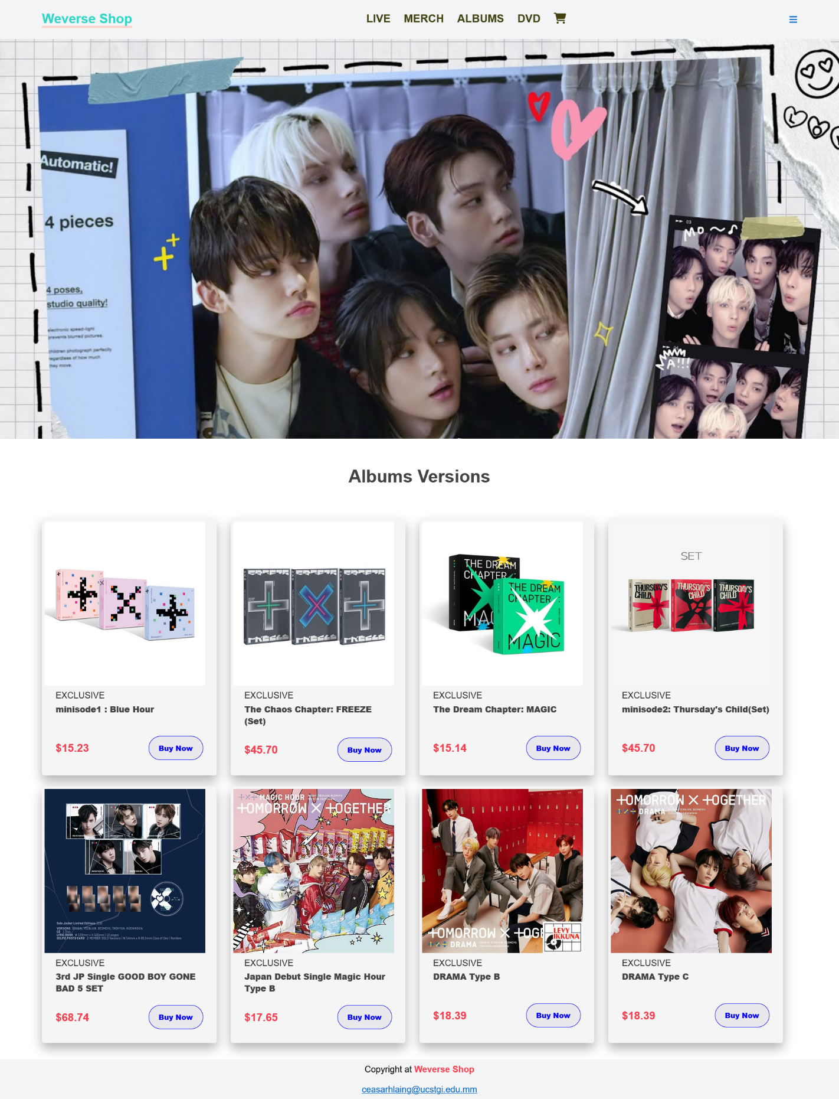

**Fig 3.8 ALBUMS Page**

Welcome to Weverse Shop! In this page, you can buy their released albums. If you click on “Buy Now” , you will reach to Payment page.

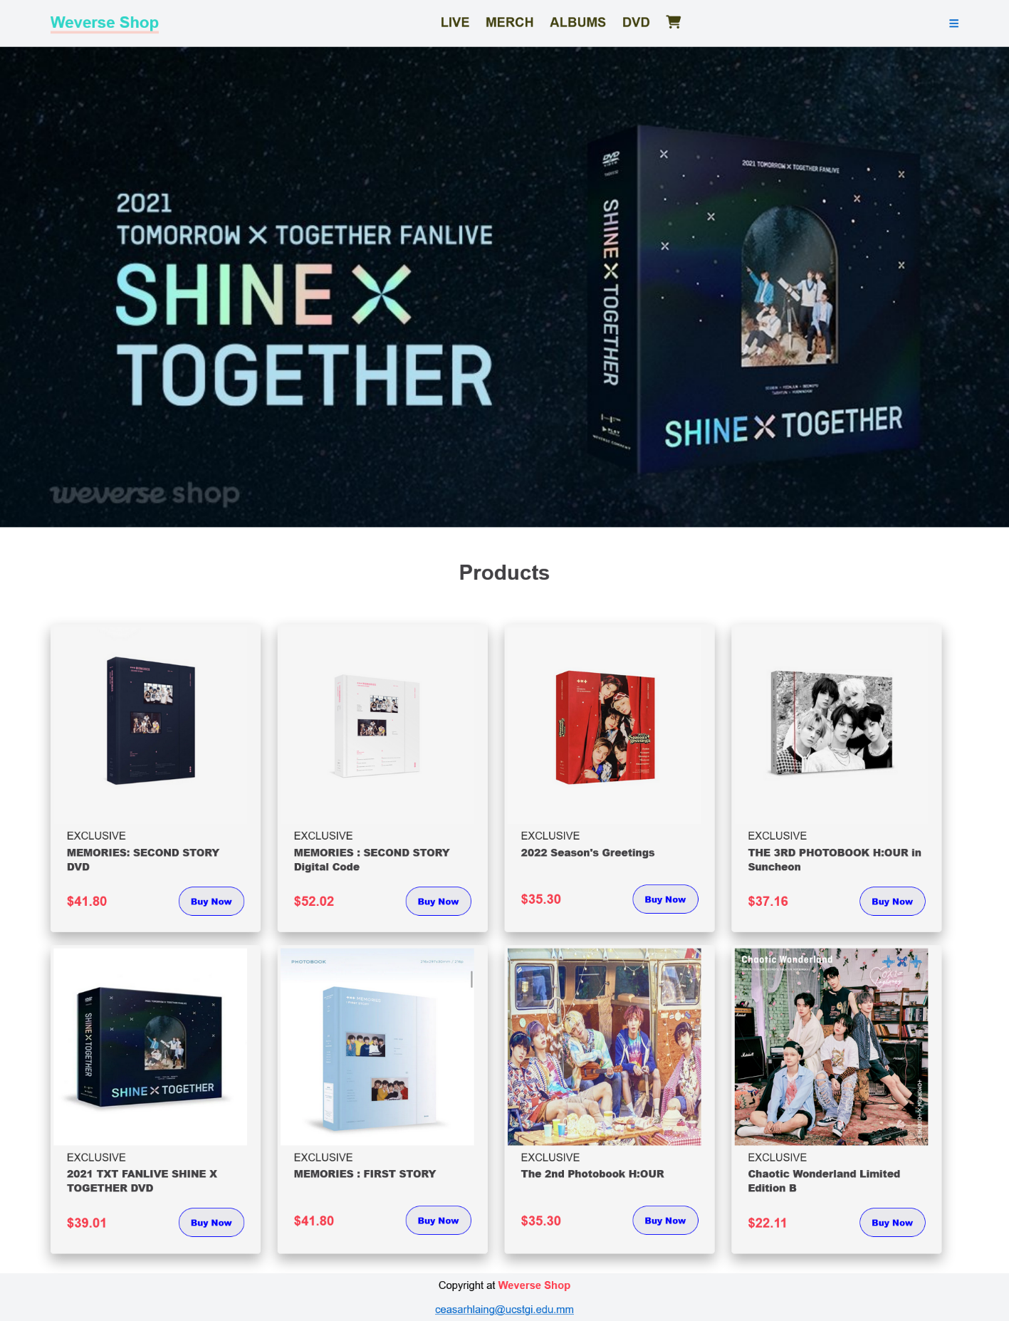

**Fig 3.9 DVD Page**

Welcome to Weverse Shop! In this page, you can buy their released DVD. If you click on “Buy Now” , you will reach to Payment page.

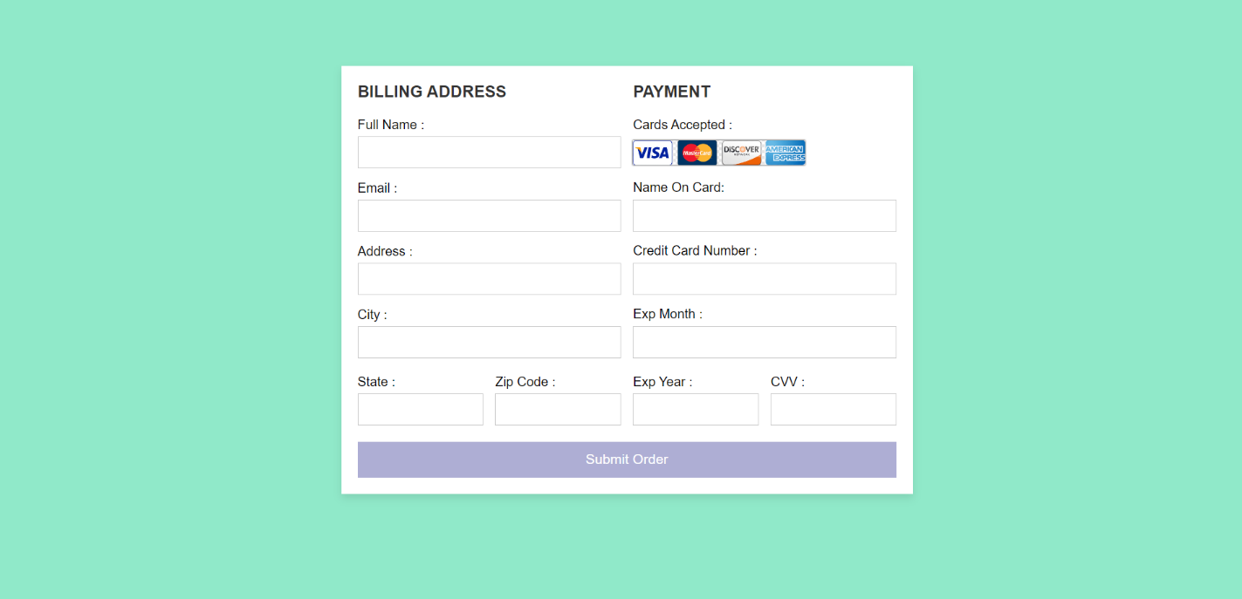

**Fig 3.10 Payment Page**

This page is where you can pay for the items you will order.

**CHAPTER (4)**

**CONCLUSION**

In this project, you can find information about Tomorrow X Together (TXT). You can listen to their songs and you can easily buy their released albums, online concert tickets and products. I hope everyone will support TXT K-pop idol group, they are a young and talented group.

**REFERENCES**

1. <https://www.youtube.com>
2. <https://www.google.com>